1. what challenges you had if you didn't finish the exercises

I finished them, hopefully they are correct :)). I didn't have any challenges.

2. describe the 2 projects (project 1 - ex 0-8, project 2 - ex 9) and what you have learned from them

I learned how to create the list that I want with one or more items on one line. Also, I learned

how to let the user "permission" to add in the list in my app (if I want to give him this access).

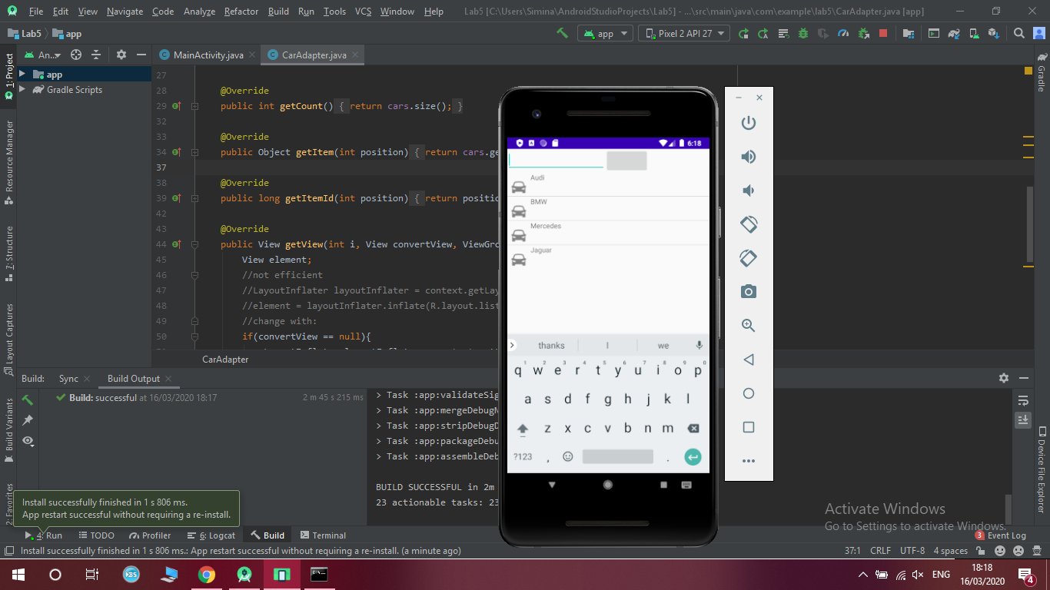

I added Volvo from the app :

